V

Advocacy Workforce Survey

**Individual workers**

National Centre for Disability Advocacy

April 2024

Contents

Tables 2

Figures 2

Abbreviations 3

Executive summary 4

Advocacy workforce survey at a glance 5

Introduction 5

Methodology 6

Caveats and limitations 7

Survey results 7

Location of respondents 7

Current role and role breakdowns 9

Demographics 9

Education 12

Employment 13

Advocate practice and wellbeing 18

Training and development 21

Systemic changes 25

National Disability Insurance Scheme (NDIS) 25

NDIS Quality and Safeguards Commission 26

Royal Commission into Violence, Abuse, Neglect and Exploitation of People with Disability (also known as Disability Royal Commission [DRC]) recommendation implementation 26

Lessons learnt 27

Survey questions 27

Survey logistics 28

Conclusion 28

Appendix 1 – Survey questions 29

Version control 29

# Tables

Table 1: What is your current role? 9

Table 2: What is the highest level of education you have completed? 12

Table 3: What is the most relevant formal training/qualification you hold for your position in the disability advocacy sector? 12

Table 4: What was your field of work before you started working in the advocacy sector? 13

Table 5: What is your employment status in the advocacy sector? 14

Table 6: During the week 23–29 October 2023, how many hours were you paid for? 15

Table 7: During the week 23–29 October 2023, how many, if any, unpaid hours did you undertake? Unpaid hours include accruing time off in lieu (TOIL). 15

Table 8: How long have you been working for your current organisation? 16

Table 9: How long have you been working in the disability advocacy sector? 17

Table 10: What is the most satisfying aspect of your work? 18

Table 11: What is the most challenging aspect of your work? 19

Table 12: What is your preference for accessing training and professional development? 22

Table 13: Apart from more advocacy, what resources (including technology) would help you perform your work more effectively? 24

# Figures

Figure 1: Jurisdiction of respondents 8

Figure 2: Age group of respondents 10

Figure 3: Comparison – Respondents who identify as First Nations 10

Figure 4: Comparison – Respondents who identify as culturally and linguistically diverse 11

Figure 5: Comparison – Respondents who identify as a person with disability 11

Figure 6: Disability sector role prior to joining the disability advocacy sector 14

Figure 7: Employment status of respondents 15

Figure 8: What training and professional development would you find useful if it was available in the next 2 years? 23

# Abbreviations

|  |  |
| --- | --- |
| Acronym | Definition |
| AAT | Administrative Appeals Tribunal |
| CALD | culturally and linguistically diverse |
| DANA | Disability Advocacy Network Australia |
| DRC | Disability Royal Commission |
| DRO | Disability Representative Organisation |
| ILC | Information, Linkages and Capacity Building |
| NCDA | National Centre for Disability Advocacy |
| NDAP | National Disability Advocacy Program |
| NDIA | National Disability Insurance Agency |
| NDIS | National Disability Insurance Scheme |
| LOTE | languages other than English |

# Executive summary

The National Centre for Disability Advocacy (NCDA) has been established with the purpose of improving access to and quality of disability advocacy services. One of the core functions of the NCDA is to provide capacity building[1] support to the sector through targeted professional development and resourcing. This is the first time the disability advocacy sector has a dedicated, national program that focuses purely on supporting the sector.

The disability advocacy sector is diverse and comprised of individuals from all walks of life. For the NCDA to fulfil its purpose, it needs to have insight into the skills and experiences of the people who work in the sector, and identify opportunities for sector upskilling and resourcing.

To understand the sector and its training requirements, as well as track trends and changes, the NCDA has developed a sector-wide survey that will be delivered annually. This is the first time since 2015 that disability advocacy staff from around Australia have been asked about who they are, their experiences, and their training needs. Where possible, a comparison has been made between the 2015 and 2023 data.

Insights from this survey include 21% of respondents identifying as a person with disability, which is an 11% increase when compared to the 2015 data. It is important that people with lived experience are employed in the sector as representation matters. 36% of respondents identify as a carer, which also brings unique lived experience to the role.

35% of respondents hold more than one role, most commonly that of both individual advocate and National Disability Insurance Scheme (NDIS) appeals advocate. This means that a portion of the sector are expected to be experts in the NDIS as well as mainstream systems. Of the managers/chief executive officers (CEOs) that responded to the 2023 survey, 64% also hold a case load.

From a training perspective, the sector would like to learn how to deliver culturally safe advocacy services from both a First Nations and culturally and linguistically diverse (CALD) lens. Additionally, the sector would like to focus on developing skills to work with people with specific disabilities, including those who use alternative communication methods, as well as develop their supported decision making practice. 44% of respondents identified formal guidance in relation to advocacy practice and advocacy-specific templates and guides as resources that would help them perform their work more effectively. This continues to be a priority area.

By understanding the sector and its evolving needs, the NCDA will be able to ensure professional development activities satisfy the sector in real time. This report also shares the survey data with the sector so it can support individuals and organisations in decision making.

# Advocacy workforce survey at a glance

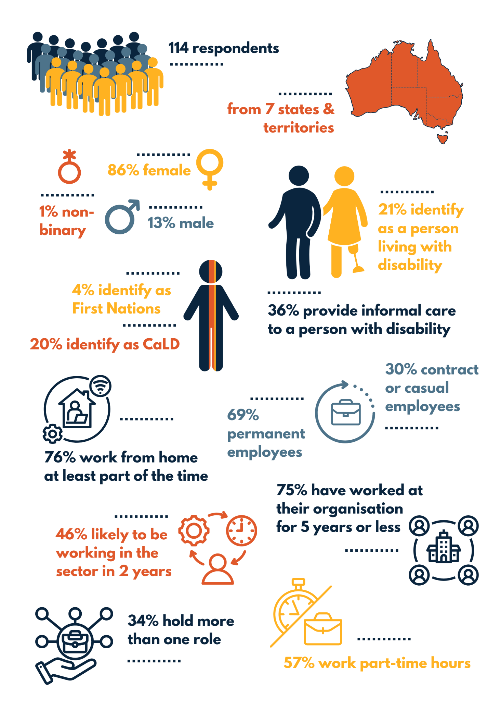

# Introduction

The National Centre for Disability Advocacy (NCDA) has been established to improve access to and quality of individual advocacy services across Australia. The NCDA’s Forward Work Plan outlines the NCDA’s objectives, including surveying the disability advocacy workforce to gain an understanding of organisations’ staffing and operations, and to identify resources, good practice, and training needs.

This is the first survey completed by individuals working in the disability advocacy sector since Disability Advocacy Network Australia (DANA) sought responses in 2015.[2] It will provide the foundation for a yearly sector-wide survey to track trends and inform the NCDA’s work to ensure activities meet the sector’s needs.

## Methodology

The survey was developed using the 2015 DANA Advocacy Workforce Survey as a base. A survey draft was circulated to the National Data Working Group[3] to seek feedback, and some modifications were made to the questions asked.

The NCDA’s remit is to provide support to National Disability Advocacy Program (NDAP) providers; however, as this survey seeks to understand the disability advocacy sector in its entirety, organisations that deliver individual disability advocacy services under non-NDAP funding streams (including state/territory-based disability advocacy funding and the National Disability Insurance Scheme [NDIS] Appeals Program) were invited to participate. The instructions advised that the survey was for people who complete paid work in the disability advocacy sector **and** undertake disability-advocacy-related work for at least 50% of their role under an individual disability advocacy funding stream.[4]

Information regarding the survey was distributed via the NCDA’s email newsletters. Additionally, every disability advocacy organisation (and key contact where known) was contacted individually via email to provide information and was asked to encourage staff participation.

The survey was conducted using Typeform. The survey was open from Monday 30 October 2023 until Tuesday 14 November 2023. 114 individuals from 7 states and territories completed the survey. Responses (2) received after the survey close date have not been included.

## Caveats and limitations

The exact number of people employed in the disability advocacy sector is unknown, which makes it difficult to ascertain the proportion of the sector that responded to the survey. Approximately 400 full-time equivalent positions are funded across all funding streams;[5] however, the results from this survey indicate that 57% of the sector works part-time, meaning the actual number of people in the sector may be much higher than the suggested number of full-time equivalent positions.

While 114 individual responses were submitted, no responses were received from Tasmania while the survey was open, meaning the results do not reflect all states and territories.

Those engaged in Disability Representative Organisation (DRO) advocacy and advocacy-like activities funded under Information, Linkages and Capacity Building (ILC) grants were excluded from this survey.

This survey sought to understand paid staff engaged in the disability advocacy sector. Citizen advocates are unpaid people who commit to a long-term connection with a person with intellectual disability who has unmet needs and is at risk of social exclusion.[6] As a result, there are no responses from citizen advocates; rather, responses have been sought from citizen advocacy coordinators.

Limited conclusions have been drawn from the survey data due to the purpose being to create a baseline. Where possible, analysis between the 2015 and 2023 surveys has occurred and been noted.

# Survey results

Survey results have been rounded to the nearest whole number for percentage breakdowns, which may mean some results exceed 100%. At times, data will exceed the total whole number as respondents were able to select multiple answers for certain questions.

## Location of respondents

113 of 114 respondents identified the state or territory where they completed the majority of their work, with 3 respondents stating they worked across 2 jurisdictions. The largest response was received from those who work in Victoria (35%), followed by Queensland (22%), New South Wales (19%), South Australia (11%), Western Australia (6%), Northern Territory (3%), nationally (2%), Australian Capital Territory (1%). No responses were received from Tasmania.

Figure 1: Jurisdiction of respondents

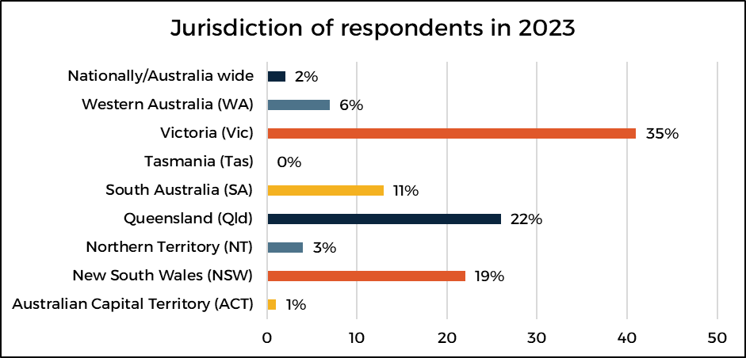

All respondents identified what location they conducted the majority of their work in. 15 respondents worked across more than one location. 49% conducted the majority of their work in capital cities, 32% in major regional centres, 24% in a rural/remote town or area, and 15% in outer urban areas. 50% of respondents in 2015 also reported working in capital cities, indicating consistency in the location of a large proportion of advocacy work.

112 of 114 respondents identified whether they worked from home. 17% work from home all of the time, 59% work from home part of the time and 24% never work from home. 101 of 114 respondents advised on their average time spent travelling to work (one way). 23% spend 20–29 minutes, 19% spend 20–39 minutes, 16% spend 10–19 minutes and more than 60 minutes, 13% spend less than 10 minutes, 11% spend 40–49 minutes, and 3% spend 50–59 minutes.

## Current role and role breakdowns

113 of 114 respondents identified their role. There was the option to select multiple roles as anecdotally it is understood that people can hold multiple roles due to how funding is distributed.[7]

Table 1: What is your current role?

|  |  |  |
| --- | --- | --- |
| Role | Percentage of respondents in 2023 | Percentage of respondents in 2015[8] |
| Individual advocate | 67% | 58% |
| NDIS appeals advocate | 31% | - |
| Systemic advocate | 20% | - |
| Citizen advocacy coordinator | 1% | - |
| Administration officer | 10% | 2% |
| Finance officer/bookkeeper | 1% | - |
| Policy/research officer | 2% | 5% |
| Manager/CEO | 12% | 29% |
| Other | 9% | 6% |

65% of respondents hold a single role, 20% hold 2 roles, 11% hold 3 roles and 4% hold 4 or more roles. This means that 34% of respondents hold more than one role.

The most common dual role was that of individual advocate and NDIS appeals advocate (20%). The next most common dual role was that of individual advocate and systemic advocate (14%). An interesting observation about holding dual roles was made concerning managers. Of the 14 respondents who identified as manager/CEO, 9 hold 2 or more roles, all of which deliver direct client services (such as individual advocate or NDIS appeals advocate). This means only 36% of managers/CEOs who responded do not hold a case load.

9% of respondents listed their role as being “other”, which included roles of intake officer, information and referral officer, ILC project officer, and solicitor. Decision support advocate was also listed, despite funding provided by the Department of Social Services (DSS) to deliver the Decision Support Pilot program ending in June 2023. This indicates that at least one organisation has continued to deliver this service without funding from DSS for that specific purpose.

## Demographics

112 of 114 respondents identified their age. The largest cohort to respond to the survey were those aged 30–39 years (23%) followed by 40–49 years (22%), 50–59 years (21%), 20–29 years (19%), 60–69 years (12%) and 70 years and over (3%). There were no individuals age 19 years or under who responded.

Figure 2: Age group of respondents

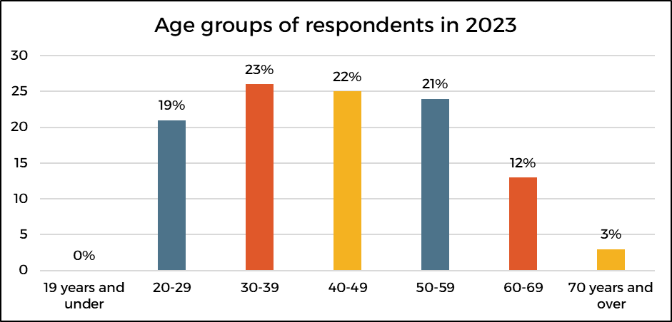

112 of 114 respondents identified their gender. 86% of respondents identified as female, 13% as male, and 1% as non-binary. This data would suggest that the majority of those working in the disability advocacy sector identify as female. There appears to be an increase in females working across the sector and a decrease in males. In 2015, 77% of respondents identified as female and 21% identified as male.

111 of 114 respondents stated whether they identified as Aboriginal and/or Torres Strait Islander and/or culturally and linguistically diverse (CALD). 5% identified as Aboriginal or Aboriginal and Torres Strait Islander and 20% identified as CALD. There appears to be an increase in First Nations people working across the sector as in 2015, only 1.6% of respondents identified as Aboriginal and/or Torres Strait Islander.

Figure 3: Comparison – Respondents who identify as First Nations

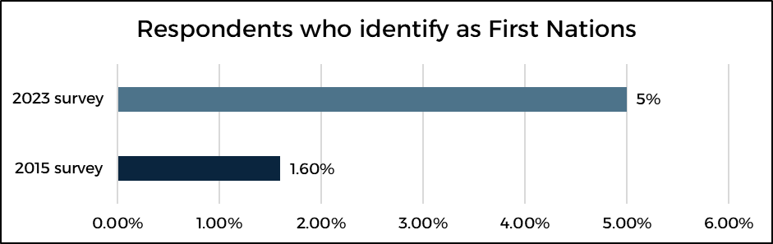

Figure 4: Comparison – Respondents who identify as culturally and linguistically diverse

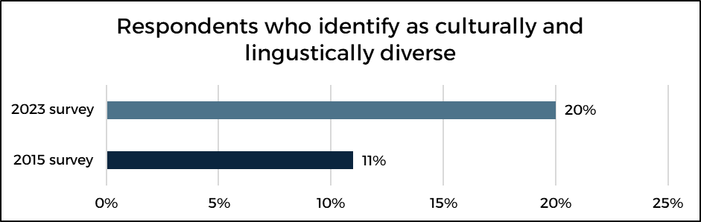

108 of 114 respondents advised on their country of birth. 78% were born in Australia and 22% were born outside of Australia. Although most respondents born outside of Australia identified their country of birth, countries have not been listed as respondents may be able to be identified by their sector colleagues.

112 of 114 respondents advised whether they spoke languages other than English and whether they were fluent in Auslan. 20% advised they spoke languages other than English, and languages spoken included German, Spanish, Portuguese, Italian, Sinhalese, Cantonese, Mandarin, Ndebele, and Shona. Only 3% of respondents advised they were fluent in Auslan.

15% of respondents advised they had used their language or Auslan skills in their advocacy work.

110 of 114 respondents advised whether they identified as living with a disability. 21% of people identified as living with a disability. This is an increase of 11% when compared with the 2015 survey data.

112 of 114 respondents advised whether they care for someone living with a disability informally; 36% advised they did. 5% of respondents identified as living with a disability and providing care for someone living with a disability informally.

Figure 5: Comparison – Respondents who identify as a person with disability

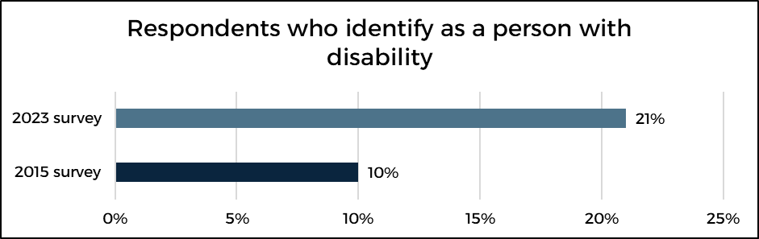

## Education

All respondents identified their highest level of education completed. 83% of respondents have completed a diploma or higher, and 68% of respondents have completed a bachelor’s degree or higher. This is consistent with data reported in 2015, with 65% of respondents having completed a bachelor’s degree or higher.

Table 2: What is the highest level of education you have completed?

|  |  |  |
| --- | --- | --- |
| Level of education | Percentage of respondents in 2023 | Percentage of respondents in 2015[9] |
| Year 11 or below (including a certificate I or certificate II) | 2% | - |
| Year 12 | 4% | 10% |
| Certificate III/certificate IV | 11% | 13% |
| Diploma/advanced diploma/associate degree | 16% | 26% |
| Bachelor’s degree | 32% | 43% |
| Graduate certificate/graduate diploma | 17% | 5% |
| Master’s degree/doctoral degree | 19% | 21%[10] |

106 of 114 respondents stated the most relevant formal training/qualification they hold for their position in the disability advocacy sector. Some respondents noted (under “other”) that their most relevant training was their lived experience.

Table 3: What is the most relevant formal training/qualification you hold for your position in the disability advocacy sector?

|  |  |
| --- | --- |
| Level of education | Percentage of respondents in 2023 |
| Year 11 or below (including a certificate I or certificate II) | 0% |
| Year 12 | 5% |
| Certificate III/certificate IV | 12% |
| Diploma/advanced diploma/associate degree | 19% |
| Bachelor’s degree | 33% |
| Graduate certificate/graduate diploma | 10% |
| Master’s degree/doctoral degree | 15% |
| Other | 6% |

## Employment

113 of 114 respondents advised of their field of work before starting in the advocacy sector. 30% of respondents chose 2 or more fields meaning the total is equal to more than 100%.

Table 4: What was your field of work before you started working in the advocacy sector?

|  |  |
| --- | --- |
| Field | Percentage of respondents 2023 |
| Administration | 13% |
| Education | 8% |
| Law | 16% |
| Social work | 17% |
| Defence | 0% |
| Allied health (e.g. psychology, speech pathology, occupational therapy, physiotherapy, podiatry, dietitian) | 2% |
| Health (e.g. dental, pharmacy, nursing, assistant in nursing, medical staff) | 4% |
| Disability (e.g. support work, disability employment service, support coordination, case management) | 39% |
| Retail/hospitality/customer service | 13% |
| Other services/community work | 18% |
| Government (federal/state/local) | 12% |
| This is my first position after study | 3% |
| Other | 6% |

97% of respondents that stated they worked in the disability sector prior to starting in the disability advocacy sector identified their previous role. 51% were support workers, 16% were managers of a disability or community service, and 10% were previously support coordinators or local area coordinators. The remaining 23% were employed in various roles such as case managers and program officers or were involved in disability employment.

Figure 6: Disability sector role prior to joining the disability advocacy sector

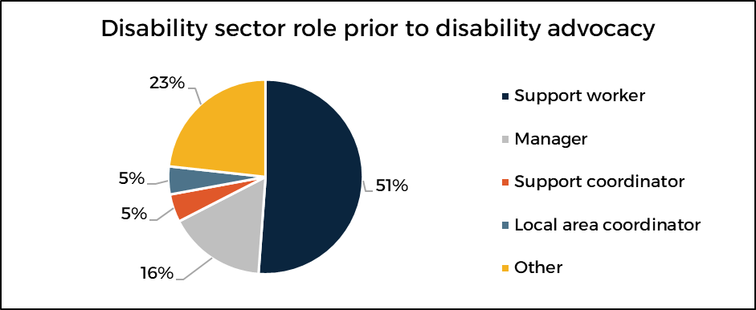

113 of 114 respondents identified their employment status. The largest responding cohort was permanent part-time employees (40%). 69% of respondents are permanent employees, and 30% are employed under a contract or casual arrangement. Interestingly, only 40% of respondents are employed full-time (both permanent and contract), and 57% are employed part-time.

Table 5: What is your employment status in the advocacy sector?

|  |  |  |
| --- | --- | --- |
| Field | Percentage of respondents in 2023 | Percentage of respondents in 2015[11] |
| Permanent full-time | 29% | 29% |
| Permanent part-time | 40% | 63% |
| Contract full-time | 11% | - |
| Contract part-time | 17% | - |
| Casual | 3% | 6% |
| Other | 1% | 2%[12] |

Figure 7: Employment status of respondents

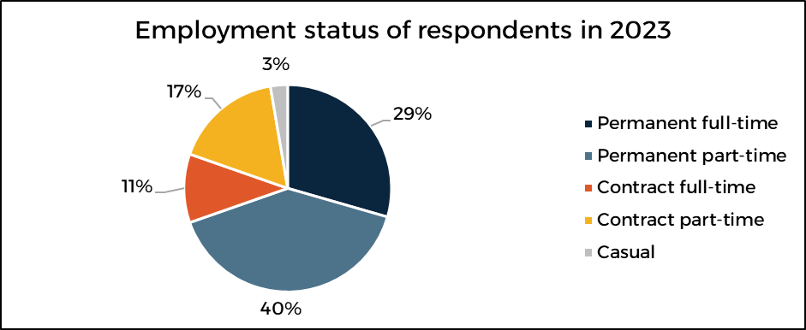

103 of 114 respondents identified how many hours they were paid for during the week of 23–29 October 2023. 50% were paid for 31–38 hours and 41% were paid for 21–30 hours, meaning 91% of respondents were paid for between 21 and 38 hours.

Table 6: During the week 23–29 October 2023, how many hours were you paid for?

|  |  |
| --- | --- |
| Field | Percentage of respondents in 2023 |
| Less than 10 hours | 0% |
| 11–20 hours | 5% |
| 21–30 hours | 41% |
| 31–38 hours | 50% |
| Over 38 hours | 4% |
| None | 1% |

107 of 114 respondents identified unpaid hours they undertook during the week of 23–29 October 2023. 50% of respondents did not undertake any unpaid leave, 21% undertook 1–2 hours, 18% undertook 3–5 hours, and 7% undertook 6–7 hours. 5% of respondents undertook 8 or more hours.

Table 7: During the week 23–29 October 2023, how many, if any, unpaid hours did you undertake? Unpaid hours include accruing time off in lieu (TOIL).

|  |  |
| --- | --- |
| Field | Percentage of respondents in 2023 |
| None | 50% |
| 1–2 hours | 21% |
| 3–5 hours | 18% |
| 6–7 hours | 7% |
| 8–10 hours | 3% |
| More than 10 hours | 2% |

113 of 114 respondents advised whether they would like to work more paid hours than they currently do. 72% of respondents said they would not, 14% said they would, 11% said maybe, and 4% were unsure.

109 of 114 respondents expressed the level of satisfaction they have in relation to their salary package. 13% of respondents were extremely satisfied, 67% were satisfied, and 20% were not satisfied.

All respondents stated how long they have been working at their current organisation. The largest cohort (29%) have spent 1–2 years at their current organisation. 23% of respondents have worked at their organisation for less than a year, and 23% have worked at their organisation for 3–5 years. In total, 75% of respondents have worked at their organisation for 5 years or less. There has been an increase of approximately 15% in the number of respondents who have been at their organisation for less than a year, when compared to 2015 data.

Table 8: How long have you been working for your current organisation?

|  |  |  |
| --- | --- | --- |
| Field | Percentage of respondents in 2023 | Percentage of respondents in 2015 |
| Less than a year | 23% | 8% |
| 1–2 years | 29% | 31% |
| 3–5 years | 23% | 32% |
| 6–10 years | 13% | 16% |
| 11–15 years | 10% | 6% |
| 16–20 years | 2% | 5% |
| More than 20 years | 1% | 2% |

113 of 114 respondents stated how long they had been working in the disability advocacy sector. As with the previous question, there has been an increase in the number of respondents who have been in their sector for less than a year when compared with 2015 data. In 2015, 8% of respondents had been working in the advocacy sector for less than a year, compared to 18% in 2023.

There has also been a notable decrease in those who have worked in the sector for 16 years or more. In 2015, 13% of respondents had been working in the sector for more than 16 years. In 2023, this number dropped to 7% of respondents – a decrease of nearly 50%. These data may indicate that long-term advocacy staff are leaving the sector. As a result, succession planning and knowledge sharing should be prioritised.

Table 9: How long have you been working in the disability advocacy sector?

|  |  |  |
| --- | --- | --- |
| Field | Percentage of respondents in 2023 | Percentage of respondents in 2015 |
| Less than a year | 18% | 8% |
| 1–2 years | 25% | 24% |
| 3–5 years | 22% | 26% |
| 6–10 years | 16% | 23% |
| 11–15 years | 12% | 6% |
| 16–20 years | 1% | 5% |
| More than 20 years | 6% | 8% |

106 of 114 respondents indicated the likelihood of them looking for another job outside of their organisation in the next 6–12 months. 15% were very likely to look for a position, 17% were likely, and 65% were not at all likely. 3% selected the “other” option and indicated that the likelihood of them looking outside of their organisation for another position would be dependent on funding and whether the position available elsewhere was a permanent full-time role, as a contract-funded job is not stable for supporting families. These results are similar to those reported in 2015.

113 of 114 respondents advised whether they would be working in the disability advocacy sector 2 years from now. 46% said yes they would, 9% said no they would not, and 44% said they were not sure. 1% selected the “other” option and indicated they would be retiring. While the “no” response has remained consistent with the 2015 data, the “yes” response has decreased from 60% to 46%.

47 of 114 respondents provided free-text responses to “Do you have any other comments regarding your employment in the advocacy sector?” Some consistent themes came through, including organisations requiring more funding to meet demand, instability in employment impacting personal and organisational future planning, disability advocacy being poorly understood and undervalued by external stakeholders, and advocates being overworked and experiencing burnout; however, the most common theme was how rewarding the “hard work” is. Comments that showcase these themes include:

*Disability advocacy is an underpaid and under[re]sourced field. Advocates have a lot of expertise in various spaces and systems and this is not as recognised as it should be. We have the power to create considerable change and we do every day. This needs to be better funded and supported to ensure systemic change can continue and the sector is skilled and sustainable.*

*Employment is uncertain, career growth is unclear, systemic and individual progress are frustratingly difficult, but the sector community is amazing and the work is so important.*

*It is rewarding however more funding needs to be provided to keep up with the demand.*

*No security of tenure makes future planning difficult, for both the service and personally for advocates.*

*I love being an advocate – it is “hard work worth doing”, and I am incredibly grateful to be part of an organisation who cares about their staff. It makes a world of difference to be working in a DPO [Disabled People’s Organisation] as my lived experience of disability is valued as an asset and I am able to do the things I need to do to keep myself stable and healthy so I can continue in this role.*

Only 2 free-text responses fell outside of the general themes. One respondent touched on how their employment contract needed to be varied to allow them to take parental leave. Another suggested that the DSS, state/territory and national peak body organisations should consider commencing a volunteer lawyer program that provides legal clinics to NDAP providers, specifically to provide corporate support.

## Advocate practice and wellbeing

All respondents shared the most satisfying aspect of their work. Most respondents selected more than one answer.

Table 10: What is the most satisfying aspect of your work?

|  |  |
| --- | --- |
| Field | Percentage of respondents in 2023 |
| Knowing I made a positive difference on an individual level | 77% |
| Empowering people with disability to exercise their rights | 70% |
| Resolving an issue/achieving a desired outcome | 67% |
| Interactions with clients and colleagues | 62% |
| Knowing I made a difference on a systemic level | 42% |
| Assisting an individual at the Administrative Appeals Tribunal for a positive outcome | 25% |
| Other | 4% |

One respondent noted under “other” that they would like to do more of “B” (referring to making a positive difference on a systemic level), but there is little opportunity to do so.

113 of 114 respondents identified the most challenging aspect of their work. 94 respondents chose 2 or more options and 18 provided free-text answers. The most challenging aspect of work was “the number of people seeking assistance being more than we can meet” with 68% of respondents choosing this option. Following closely behind was “completing advocacy for the same issue repeatedly as the system does not change quickly” with 65% of respondents selecting this answer. 49% of respondents also selected “increased complexity of matters”.

Table 11: What is the most challenging aspect of your work?

|  |  |
| --- | --- |
| Field | Percentage of respondents in 2023 |
| The number of people seeking assistance being more than we can meet (unmet demand) | 68% |
| Completing advocacy for the same issue repeatedly as the system does not change quickly | 65% |
| Increased complexity of matters | 49% |
| The lack of time or resources to engage in professional development | 34% |
| Increased reporting and compliance requirements | 33% |
| Being able to meet the expectations of governing bodies | 19% |
| Having a good work–life balance | 18% |
| Other | 16% |

The free-text responses were diverse and touched on the inaccessibility of systems, programs, and society in general; lack of funding and capacity to deliver advocacy services; and barriers to performing advocacy work. Responses included:

*Being met with resistance from other services when trying to advocate for someone’s rights. The complex systemic and bureaucratic barriers which cause rights denials to disabled young people. The emotional toll that comes with advocacy work.*

*inaccessibility of systems and programs* and *dealing with the NDIS.*

*The heavy burden that we see the issues on the ground and seeing how inefficiently government is spending money, when it could be more effectively spent to support people with disabilities. Also the overall frustration of how society is structured to exclude people with disabilities.*

*The stress of representing parents with intellectual disabilities in long running care matters.*

*The blatant declining behavior of service providers,* and *providers not working collaboratively.*

*Nothing change[s] even [though] the same issue has been reported multiple times* and *increased number of clients with insoluble problems arising from systemic issues.*

Some respondents also noted that it can be challenging to work with clients who are demanding throughout their interaction with the advocate and clients who have unrealistic expectations.

112 of 114 respondents specified how often they feel stressed/overwhelmed at work. 2% never feel stressed, 24% rarely feel stressed, 41% feel stressed once or twice per week, 25% feel stressed often, and 6% feel stressed all of the time. 2% advised “other” and indicated that there are stretches of time that feel completely overwhelming and then there are periods when things are calm.

104 of 114 respondents provided free-text answers in relation to the cause of stress/overwhelm in their work. There were consistent themes with the most reported cause of stress being unmet demand. There were also themes of vicarious trauma, unsustainable workloads, and not having enough time to complete all the work. Responses include:

*Clients becoming distressed during phone calls and heavy workloads.*

*Having such limited resources and the organisation trying to do too much with no further resources e.g. applying for grants, systemic advocacy, collaborations, hosting interns ... these are all additional. There [are] just not enough resources and people in the organisation are taken advantage of because they are so passionate, and then they burn out.*

*I work in intake, so clients in extremely difficult/distressing situations which the centre is unable to help with (due to capacity/time frame) and managing the client's experience in this instance.*

*When multiple people experience crisis simultaneously, it can be very overwhelming. Dealing with bureaucratic systems on peoples' behalf where the[re] is no sense of urgency on the part of the systems is extremely stressful.*

*Complexity of cases where there is high risk to clients. Abusive calls. Threats by providers.*

Some respondents also noted that their cause of stress is due to issues with their manager or executive leader.

110 of 114 respondents advised of organisational support for dealing with stress/overwhelm at work. 91% of respondents stated that their organisation did provide support, 5% said their organisation did not provide support, and 4% selected “other” and submitted a free-text response. These written responses showed that some support was offered but at times it was not adequate; more resources and learning opportunities were required by managers; and when the funding was available, respondents had access to external supervision, which is no longer practical on reduced funding.

90 of the 100 respondents who answered “yes” to the previous question provided free-text responses to identify what kind of support their organisation provides for stress/overwhelm at work. There were themes identified, with 67% of respondents noting that the employee assistance program (EAP) is offered and 46% of respondents attend external supervision. 39% use internal/informal supervision and debriefing as a way to manage stress, and 13% of respondents advised their organisation encourages flexible working arrangements such as working from home or taking leave to manage stress.

Of the 6 respondents who answered “no” to the previous question, 5 provided free-text responses to identify the supports they would benefit from in dealing with stress/overwhelm at work. Having access to psychological supervision, debriefing, counselling and EAP was viewed as helpful by 3 respondents, and the remaining 2 respondents advised having support to complete intake and having less of a client load would be beneficial. Throughout the survey there were free-text responses indicating that having access to additional leave, such as “mental health days” in addition to personal leave would be valuable in managing stress.

## Training and development

113 of 114 respondents identified whether they attended any training during the past 12 months that helped them to build their skills and knowledge. 78% advised they had and 22% advised they had not. 75 of 88 respondents who advised they attended training provided free-text responses describing the training they attended and whether there was anything in particular they liked about it. The most common type of training related to trauma, most notably trauma-informed practice and vicarious trauma, with 12 respondents (16%) listing this area. Following closely behind was training relating to cultural awareness and culturally safe practices. 11 respondents (14%) attended general cultural awareness training, and of those, some attended specialised First Nations cultural awareness and CALD competency training.

112 of 114 respondents identified their preferences for accessing training and professional development. 93 of 112 respondents selected more than one answer. Online access was the top preference; 76% of respondents selected this method. This differs significantly from the 2015 results, as online training was only selected by 5% of that year’s respondents, and the number one preference was for training provided in the local area (45%).

Table 12: What is your preference for accessing training and professional development?

|  |  |
| --- | --- |
| Field | Percentage of respondents in 2023 |
| Online | 76% |
| Group training at your workplace | 63% |
| Training provided in your local area/community | 56% |
| Attend a conference | 48% |
| Travel within your state to train with other colleagues/organisations | 46% |
| Travel interstate for training | 19% |
| Other | 0% |

102 of 114 respondents identified on a Likert scale the training and professional development they would find useful if it was available in the next 2 years. Culture-based training, working with people with specific disability and complex issues, as well as supported decision making and using alternative communication had the highest weighted averages.

Figure 8: What training and professional development would you find useful if it was available in the next 2 years?

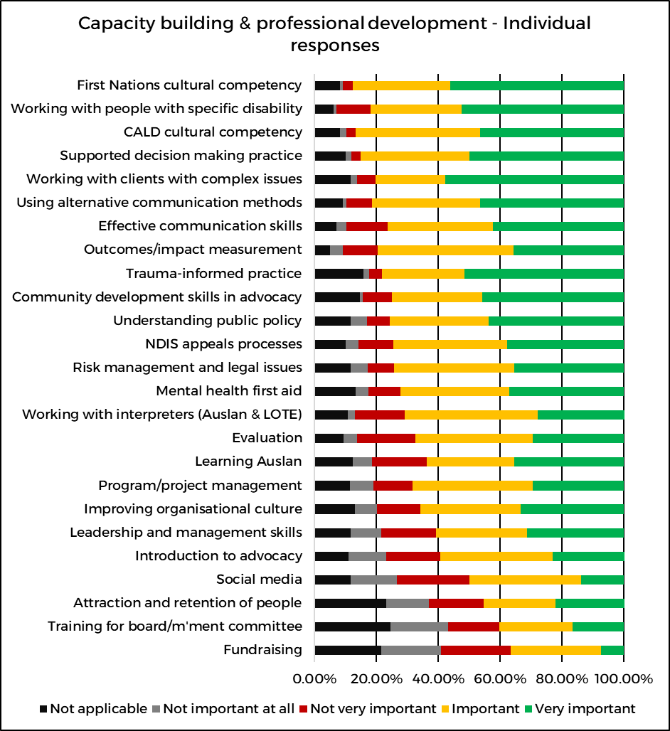

Abbreviations

CALD = culturally and linguistically diverse; LOTE = languages other than English; NDIS = National Disability Insurance Scheme

113 of 114 respondents identified the resources (including technology and apart from more advocacy) that would help them perform their work more effectively. The 2 highest responses were formal guidance in relation to advocacy practice and advocacy-specific templates and guides, both being selected by 44% of respondents.

Table 13: Apart from more advocacy, what resources (including technology) would help you perform your work more effectively?

|  |  |
| --- | --- |
| Field | Percentage of respondents in 2023 |
| Formal guidance in relation to advocacy practice | 44% |
| Advocacy-specific templates and guides | 44% |
| More effective client record management system | 36% |
| Improved information and communication technology (including updated computers) | 26% |
| Office space, aesthetics, workstation set-ups/furniture | 22% |
| Nil – we are well resourced | 12% |
| Other | 12% |
| Motor vehicle fleet (modern, safe, enough vehicles) | 11% |
| Not sure | 8% |

The free-text responses listed under “other” included more consistency across advocacy organisations and more resources relating to systemic advocacy collaboration, funds to hire more staff, and for the government to listen to the sector. One respondent suggested having specialised channels to speak to government agencies about issues. Having more innovative ways of working from home was deemed beneficial by 2 respondents, and 2 respondents expressed a desire to see independent advocacy recognised as an occupation.

37 of the 50 respondents who selected “advocacy-specific templates and guides” in the previous question provided free-text responses identifying the advocacy-specific tools, areas, or topics that would be useful. NDIS guidance concerning access criteria, good evidence for Administrative Appeals Tribunal (AAT) cases, and navigating processes were listed most commonly with 35% of respondents noting these areas. Disability Support Pension was the next most common topic with 14% of respondents advising that example letters for applications would be useful.

13 of 37 (35%) respondents advised that advocacy-specific guidelines would be useful, including outreach guides, intake regulation, and navigating specific systems. 3 respondents listed that having a central place where organisations can access and share templates and guides and collaborate with organisations would be useful. Some responses touched on advocacy skill sets:

*I would like to learn more about specific disabilities so that I can provide better guidance about reasonable adjustments; would like to learn strategies for dealing with different kinds of issues.*

*Management of conflict; upskilling/knowing our role; shared resources at national level; shared ongoing systemic work at national level.*

*NDIS applications, explanation to clients on what the role of an advocate is, conversation starters to assist in empowering people (it can be hard in the moment to not just agree to doing something for someone who is struggling).*

# Systemic changes

It is not the role of the NCDA to coordinate or undertake systemic activities but to collect information and analyse emerging systemic issues that are informed by the disability advocacy sector. The NCDA is uniquely placed to gather information relating to systemic issues as it engages with practising advocates and advocacy staff regularly. The NCDA has shared the full free-text responses to the final 3 questions of the individual worker survey with the Policy and Advocacy team at DANA to assist them in understanding the views of advocates in relation to the systemic issues DANA is currently working on. Advocacy organisations are invited to contact the NCDA about systemic work they are undertaking to see if the survey results provide any insights into the particular issues.

## National Disability Insurance Scheme (NDIS)

94 of 114 respondents provided free-text responses to the question “If you could change two things about the NDIS for people with disability, what would it be?”. Similar to previous open-text questions, there were consistent themes among the responses. The top 3 changes suggested were to make the system easier to navigate (including making access and other processes accessible), for the National Disability Insurance Agency (NDIA) to improve its communication with participants and their supporters, and for NDIA staff to be upskilled in understanding different disabilities and working with people with disability. Responses that articulate these themes include:

*That the gatekeeping and inaccessibility of staff that you need to speak with is stopped as a practice. That they leave a message from their private number phone call and a contact email or time they will call you back. That staff have better training and give consistent information. That many more staff with disabilities are employed in order to change the culture which seems to have goals of cost cutting at any human cost.*

*Faster and more efficient processes and time frames; less bureaucracy and red tape and more human understanding, flexibility, trauma-informed approaches.*

*Have a specific team for NDIS clients in crisis, make it easier for clients to fix small problems with plans.*

*[A] streamlined process that makes it easy and efficient to access and better communication around what supports are available within and outside the NDIS.*

Other themes in relation to change included the NDIA delivering consistent and transparent decisions and being inclusive of people with disability.

## NDIS Quality and Safeguards Commission

81 of 114 respondents provided free-text responses to the question “If you could change two things about the NDIS Quality and Safeguards for people with disability, what would it be?”, with 4 very strong themes emerging. 32% of respondents identified that compliance measures should be increased for those found to be doing the wrong thing. 31% of respondents identified that the Commission should provide feedback to the complainant, and 23% of respondents identified that the Commission should be proactive in its approach to safeguarding people with disability, including unannounced visits to closed environments. 20% of respondents specifically noted that communication between the Commission and people with disability should be improved. Responses that highlight these themes include:

*Their response time. I cannot tell you how often I have received PCs [phone calls] saying "We triage all cases and your issue is important to us". It makes the client feel unimportant. Plus, they have no teeth and often side with the provider. I want them to be effective in their role – to make changes that assist people with disability.*

*You need people empowered to visit and assess service provision with minimal notice – to ensure safety of participants. You need to shut down service providers who are rorting the system for money and ensure that associated individuals are locked out of providing any future services.*

*Have them provide feedback around your ongoing matter. Have them support the individual and not the service provider.*

Two responses fell outside of the general themes. One included providing easy-to-understand whistle-blower guidelines and protection, including addressing “grey areas” of confidentiality vs duty of care vs consent, and another suggested that the Commission be changed to a tribunal with jurisdiction to award compensation and impose penalties.

## Royal Commission into Violence, Abuse, Neglect and Exploitation of People with Disability (also known as Disability Royal Commission [DRC]) recommendation implementation

67 of 114 respondents provided free-text responses to the question “What are the top three recommendations from the Disability Royal Commission that should be prioritised for implementation?”. 11 respondents provided 1 recommendation area to be prioritised, 12 provided 2 recommendation areas to be prioritised and 42 provided 3 recommendation areas to be prioritised. 2 responses were unable to be analysed.

37% of respondents supported recommendations relating to increased advocacy funding, 31% of respondents recommended enacting disability rights legislation, and 16% of respondents supported recommendations relating to housing. Ending segregation in employment, education, and group homes was also strongly supported.

Some respondents noted that they were unable to comment on which recommendations they saw as priority areas as they had not read all of the recommendations.

# Lessons learnt

## Survey questions

After analysing the responses, especially the free-text comments, it is apparent that some questions should be altered to maximise the usefulness of the data collected.

Question 1 “What is your current role?” should have additional options added, including:

* intake officer
* solicitor
* information and referral officer.

Additionally, the role of manager/CEO should be split into:

* team leader/manager
* executive leadership.

By adding and separating roles, a more nuanced analysis can occur, especially in relation to those who hold dual roles and case loads.

Question 3 “Which of the following best describes your location?” should have an additional option of “statewide” as this was the most frequently listed response under “other”.

An additional question should be asked after question 23 “During the week 23–29 October 2023, how many, if any, unpaid hours did you undertake?”. The question should seek to understand whether the number of unpaid hours (if any) undertaken during that week is a normal part of employment, less than usual, or more than usual. This would assist in understanding whether there are consistent demands on the workforce that result in unpaid work.

An additional question should be included in the survey to understand the conditions and benefits advocacy staff currently receive. This information may be able to assist advocacy organisations in beginning a conversation about employment conditions. It may also assist in shedding light on different and innovative ways advocacy organisations support these staff.

Question 41 “You selected yes (in relation to attending training during the past 12 months that helped build your skills and knowledge). What training did you attend? Was there anything in particular that you liked?” could be altered to make the question clearer or separated into single questions. Many respondents stated what training they attended, but not as many shared what they liked about the training. Having information about what the sector prefers and enjoys will assist the NCDA in tailoring training programs.

Question 5 “If you work away from home, on average, how many minutes does it take you to get to work?” could be removed from the survey as it does not appear to provide useful actionable information.

## Survey logistics

The NCDA received feedback that a sector-wide survey being conducted during November caused undue stress to some due to the number of competing priorities: preparing and executing annual general meetings, grant applications, and reporting. This time in 2023 was also particularly difficult for the sector as the final report for the Royal Commission into Violence, Abuse, Neglect and Exploitation of People with Disability was handed down weeks prior, and the sector was awaiting the outcomes of the NDIS Review. Feedback was received that it would have been of benefit for the survey to remain open for longer, as this time of year was particularly busy.

In acknowledgement, the NCDA proposes that the sector-wide survey be conducted in August. Additionally, the lead-in time will be increased to ensure as many people as possible are provided with information about the survey in advance. The survey will also remain open for 3 weeks instead of 2 weeks.

The survey was intended to build understanding of the disability advocacy sector; however, as mentioned earlier, many disability advocacy organisations receive funding to deliver services other than disability advocacy, resulting in a person holding more than one role. The initial instructions advised people to complete the survey only if at least 50% of their position was funded by a disability advocacy funding stream; however, feedback was received that some people working in the sector would not know this information, and it could act as a barrier to survey completion. To ensure information about the disability advocacy sector is the predominant information captured, more messaging should occur about who should complete the survey prior to the survey being executed.

# Conclusion

The NCDA sincerely thanks all survey respondents for taking the time to not only complete the survey but also provide profound and nuanced responses, especially in relation to systemic issues faced by people with disability. The NCDA acknowledges that the survey was long; however, with the participation of the sector, there is now baseline data that can continue to be built upon.

The NCDA is committed to continuous improvement and welcomes feedback in relation to all its activities. If there is specific feedback concerning the workforce survey, please email [**ncda@dana.org.au**](mailto:ncda@dana.org.au)**.**

# Appendix 1 – Survey questions

A copy of the survey questions can be viewed in both word and PDF via the following links:  
[Advocacy Workforce Survey – Individual (Word 130KB)](https://ncda.org.au/wp-content/uploads/2023/10/2023-Advocacy-Workforce-Survey-Individual-Final-v2-202310.docx)  
[Advocacy Workforce Survey – Individual (PDF 170KB)](https://ncda.org.au/wp-content/uploads/2023/10/2023-Advocacy-Workforce-Survey-Individual-Final-v2-202310.pdf)

# Version control

| **Version** | **Summary of changes** | **Approval date** | **Approved** |
| --- | --- | --- | --- |
| 1.0 | Approval of document | 16/04/2024 | NCDA Manager |



Email: ncda@dana.org.au

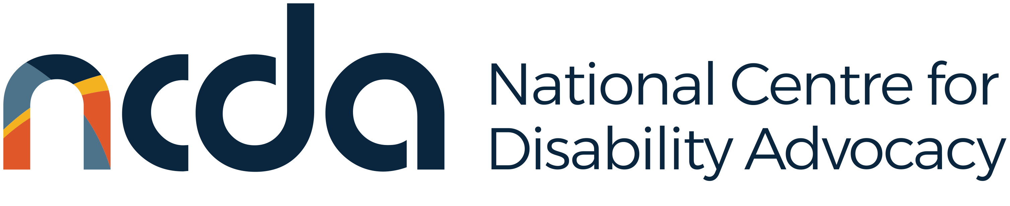

1. These activities include both capacity and capability building.
2. Disability Advocacy Network Australia, 2015, [Advocacy Workforce Survey 2015 results](https://www.dana.org.au/wp-content/uploads/documents/publications/PUBLICATIONS%20-%20Advocacy%20Workforce%20Survey%202015.pdf).
3. The NCDA chairs and convenes the National Data Working Group. The working group consists of at least one disability advocacy organisation from every state and territory and represents every model of disability advocacy.
4. A disability advocacy funding stream includes NDAP, NDIS appeals program, and state-funded disability advocacy programs.
5. DANA is aware of approximately $60 million per year of total advocacy funding spread across federal, state, and territory government funding. An operating cost of $150,000 per year per advocate has been used to determine the amount of full-time equivalent positions. Disability Advocacy Network Australia, 2023, *Submission:* [A strong, sustainable future: addressing capacity shortfalls for a strengthened disability advocacy sector](https://www.dana.org.au/wp-content/uploads/2023/11/Pre-Budget-Submission-from-the-Disability-Advocacy-Sector_14-Nov-2023.pdf),p. 4.
6. Side by Side Advocacy, no date, [About Citizen Advocacy.](https://sidebysideadvocacy.org.au/citizen-advocacy/)
7. Funding for advocacy is often calculated by population data meaning that an organisation may receive funding that equates to less than a full-time position. Organisations create “dual roles” from different funding streams to stretch funding and resources.
8. Different advocate roles were not separated in the 2015 survey.
9. Respondents were able to select more than one option.
10. Included postgraduate degree, master, and doctorate.
11. Permanent and contract status was not separated in the 2015 survey.
12. “Other” represents volunteer for 2015 survey results.